VENANGO TECHNOLOGY CENTER
JOINT COMMITTEE
1 Vo-Tech Drive
Oil City, Pennsylvania 16301

MINUTES

October 5, 2020

The regular meeting of the Venango Technology Center Joint Committee was held this evening in the Conference Room of the Venango Technology Center, 1 Vo-Tech Drive, Oil City, PA 16301. Mrs. Neely called the meeting to order at seven o’clock (7:00) p.m.

Mrs. Neely asked the members to pause for a moment of silence.

Mrs. Neely asked the members to stand for the pledge of allegiance.

Roll Call: Present: Robert Blauser, Todd Carson, James Come, James Disque, Troy Johnston, Don
Judy, Mark Marterella, Misty Nalepa, Shari Neely

Absent: Jeff Thomas

Also Present: Mr. Mario Fontanazza, Dr. Lynda Weller (via phone)

Mrs. Neely stated the Joint Committee members had received copies of the Minutes of the September 8, 2020 meeting in the mail. She asked if there were any additions, corrections or deletions.

Mr. Carson, seconded by Ms. Nalepa, moved to approve the Minutes of the September 8, 2020 meeting as submitted.

Roll Call: Ayes: Robert Blauser, Todd Carson, James Come, James Disque, Troy Johnston, Don
Judy, Mark Marterella, Misty Nalepa, Shari Neely

Nayes: None, motion carried.

The Treasurer and Secretary’s Report as of 10/5/20 were submitted for information.

Mr. Carson, seconded by Mr. Disque, moved to accept the Treasurer and Secretary’s Report as of 10/5/20 as submitted.

The motion was unanimously approved.

A list of bills from 9/9/20 – 10/5/20 in the amount of $724,905.08 was presented for approval.

Mr. Disque, seconded by Ms. Nalepa, moved to approve the list of bills as presented.

Roll Call: Ayes: Robert Blauser, Todd Carson, James Come, James Disque, Troy Johnston, Don
Judy, Mark Marterella, Misty Nalepa, Shari Neely

Nayes: None, motion carried.

Under Communications, Mr. Fontanazza discussed the Professional Advisory Committee. He also discussed the Calendar of Events for the month of August and the Monthly Enrollment Report as of 10/5/20 were submitted.

Mrs. Neely requested approval of the action items as presented. Item 8. a) i.- vi. in one motion.

Mr. Carson, seconded by Ms. Nalepa, moved to approve action items i.- vi. as follows:

- Approve Tuition increase of $300.00 for Practical Nursing for the 2021-2022 school year to
$15,450.00.
- Approve Tori Burkhart as a Perkins Instructional Aide at a salary of $12,500.00 prorated based on the number of days worked.
- Approve copier lease with Hagan Business Machines for Oil City & Warren Practical Nursing at a monthly cost not to exceed 469.98 for 2 Toshiba 5518A machines plus maintenance fee. – Funding Practical Nursing
- Approve the termination of the oil and gas lease.
- Approve board policy changes as presented.
- Approve list of equipment for disposal.

Roll Call: Ayes: Robert Blauser, Todd Carson, James Come, James Disque, Troy Johnston, Don
Judy, Mark Marterella, Misty Nalepa, Shari Neely

Nayes: None, motion carried.

Mr. Fontanazza reviewed his Issues/Activities for September 2020.

Mrs. Neely asked if there was any old business.

None was noted.

Mrs. Neely asked if there was any new business.

None was noted.

Upon motion by Ms. Nalepa, seconded by Mr. Carson, the meeting adjourned at seven fifteen (7:15) p.m.

Recorded by
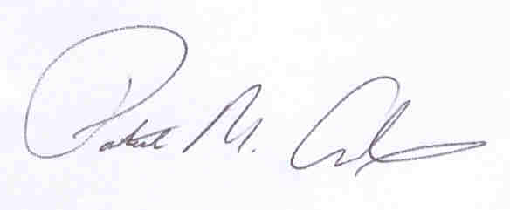
Patrick M. Adams
Secretary, Joint Committee

